A short survey about whether you read instructions
Results
Report generated: September 25, 2026
Survey published: September 25, 2026

Table of Contents
Survey Overview
Survey Results

Survey Overview

Instructions Provided To Respondents
Welcome — this is a real Candor survey, the same thing your people would see. It takes about two minutes, and there's no name or email field anywhere in it: you came to look around, not to be looked up. One heads-up — your answer to one question decides whether you ever see the next one.

Respondent Metrics
Respondents: 20
First Response: September 25, 2026
Last Response: September 25, 2026

Survey Results
The charts below show the responses to each survey question.

#1 A new gadget arrives. The instructions are:
20 responses
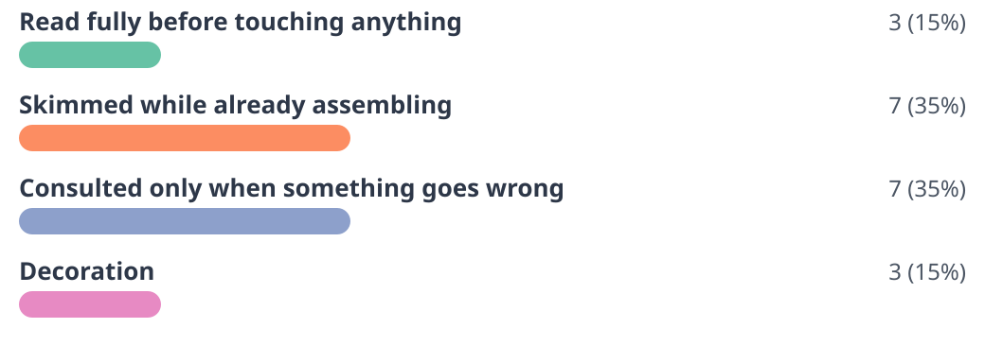

#2 Recipes:
20 responses


#3 Have you ever finished assembling furniture and had parts left over?
20 responses
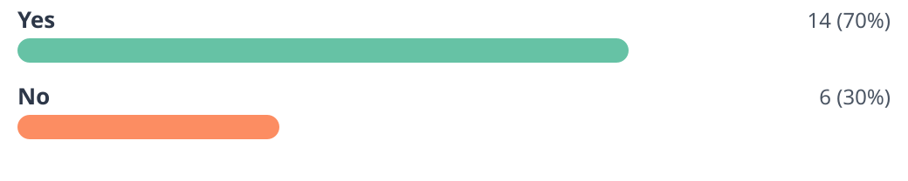

#4 And how do you feel about those parts?
14 responses
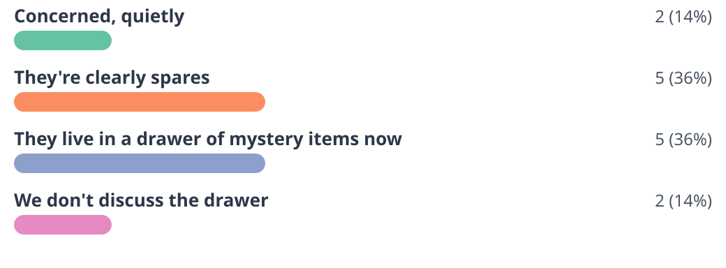

#5 Warranty cards:
20 responses
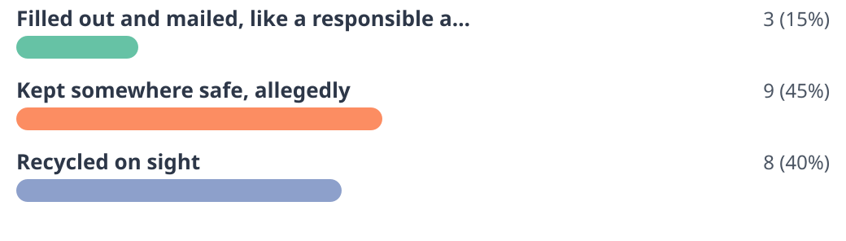

#6 What’s the best instruction you’ve ever ignored — and how did it go?
11 responses
- Read all instructions before beginning. I began. (1 person)
- Tighten every screw at the end. I tightened them at the start. The drawer closes at an angle now. (1 person)
- Rest the dough for an hour. We were hungry. The bread was fine. (1 person)
- Assemble on a soft surface. The floor has a scratch I now call character. (1 person)
- Let the paint dry overnight. It had a fingerprint by nine. (1 person)
- Two-person assembly. It took one person and one afternoon. (1 person)
- Wash before first use. It was a spatula. It was fine. (1 person)
- Do not stand on the top step. I did not. I thought about it a lot. (1 person)
- Keep your receipt. (1 person)
- None. I read them, and it went the way they said it would. (1 person)
- Charge fully before first use. I used it at forty percent and nothing bad happened. (1 person)

Exported September 25, 2026

